SCH4U -AP January 2018
Answers: Review for Bonding Test: Answers
- Compare the following terms:
- Orbit, orbital
- Bohr’s model of the atom, quantum mechanical model
- Polar molecule, non-polar molecule
- Electron configuration, orbital diagram
- p orbital, s orbital, hybrid orbital
- London forces, dipole-dipole forces
- Dipole-dipole forces , hydrogen bonding
- Covalent bond, VanderWaals forces
- Sigma bond, pi bond

- Draw the electron configuration for:
- Manganese
1s² 2s² 2p⁶ 3s² 3p⁶ 4s² 3d⁵
- antimony (short form)
[Kr] 5s² 4d¹⁰ 5p³
- the phosphorus ion
1s² 2s² 2p⁶ 3s² 3p⁶

- Draw the orbital diagram for:
- Titanium (short form)
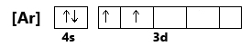
- Fe²⁺
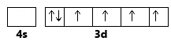
- Carbon in its promoted state
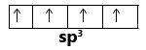
- Copper (short form)
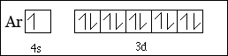

- Cd²⁺ (short form)
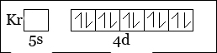

- Potassium’s 19th electron
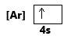

- Valence electrons of aluminum

- Draw the bonding orbitals and label the orbitals for:
- PCl₃
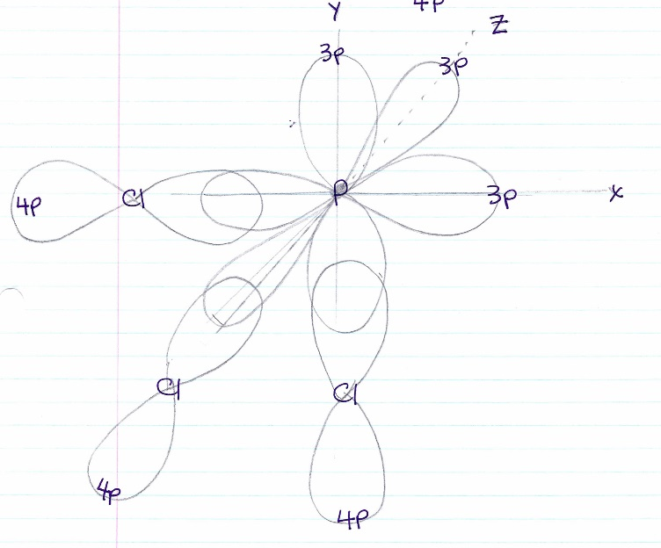

- SiCl₄
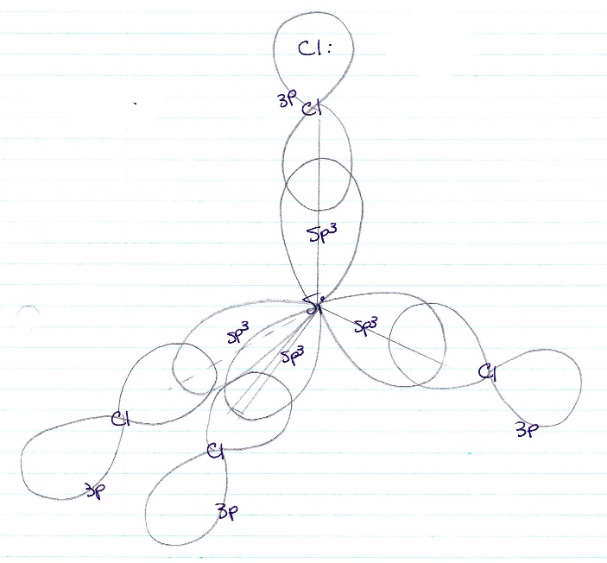

- CH₃F
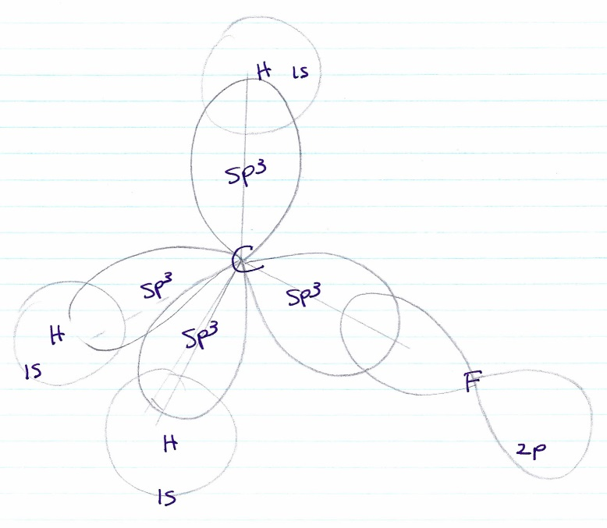

- Draw structural diagrams and identify sigma and pi bonds for:
a) O₃
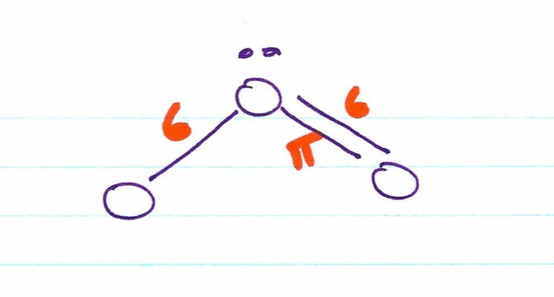

b) HNO₃
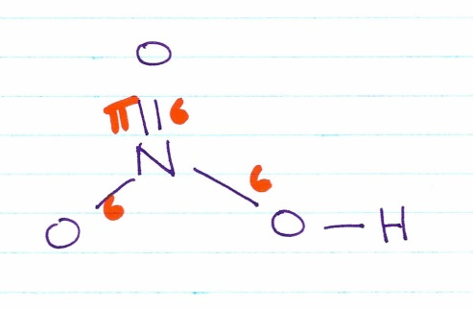
c) HCN
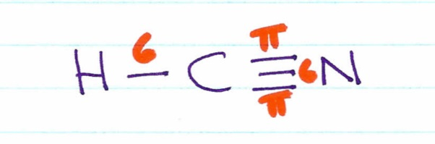

6. Draw and name 3-D shape for:
a) HCN
b) CO₃²⁻
c) PBr₃
d) SiCl₄
e) PBr₅
f) SF₄
g) SF₆
h) BrCl₃
i) XeF₂
j) XeF₄
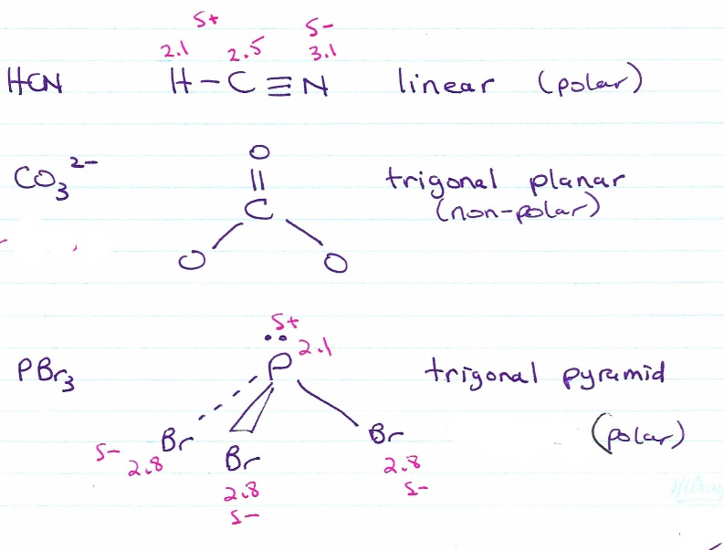
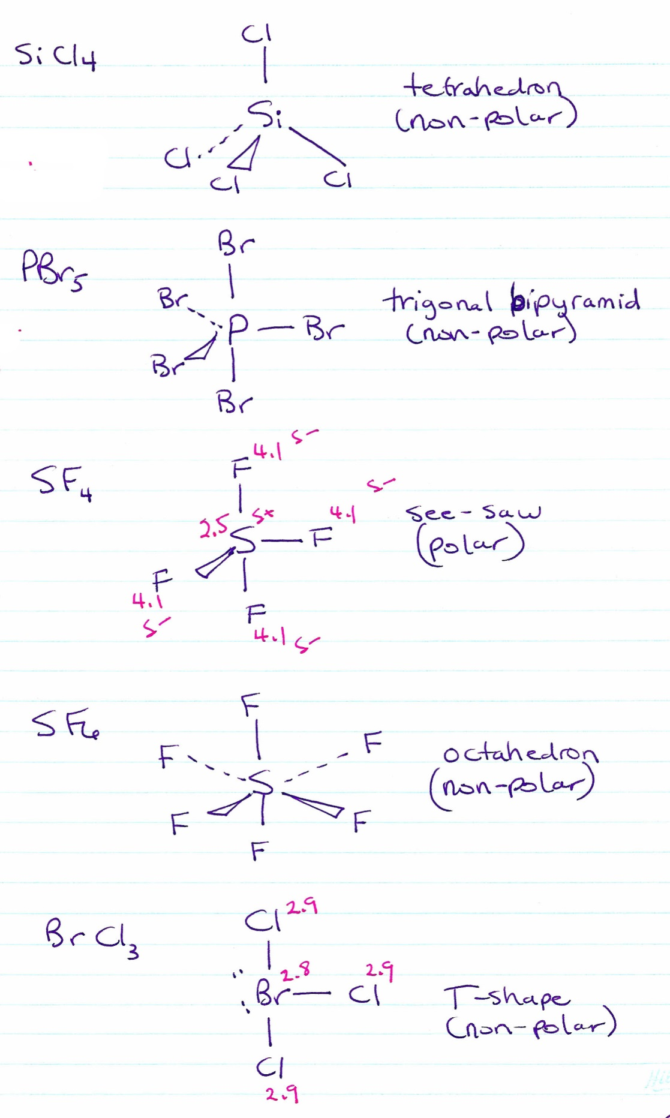

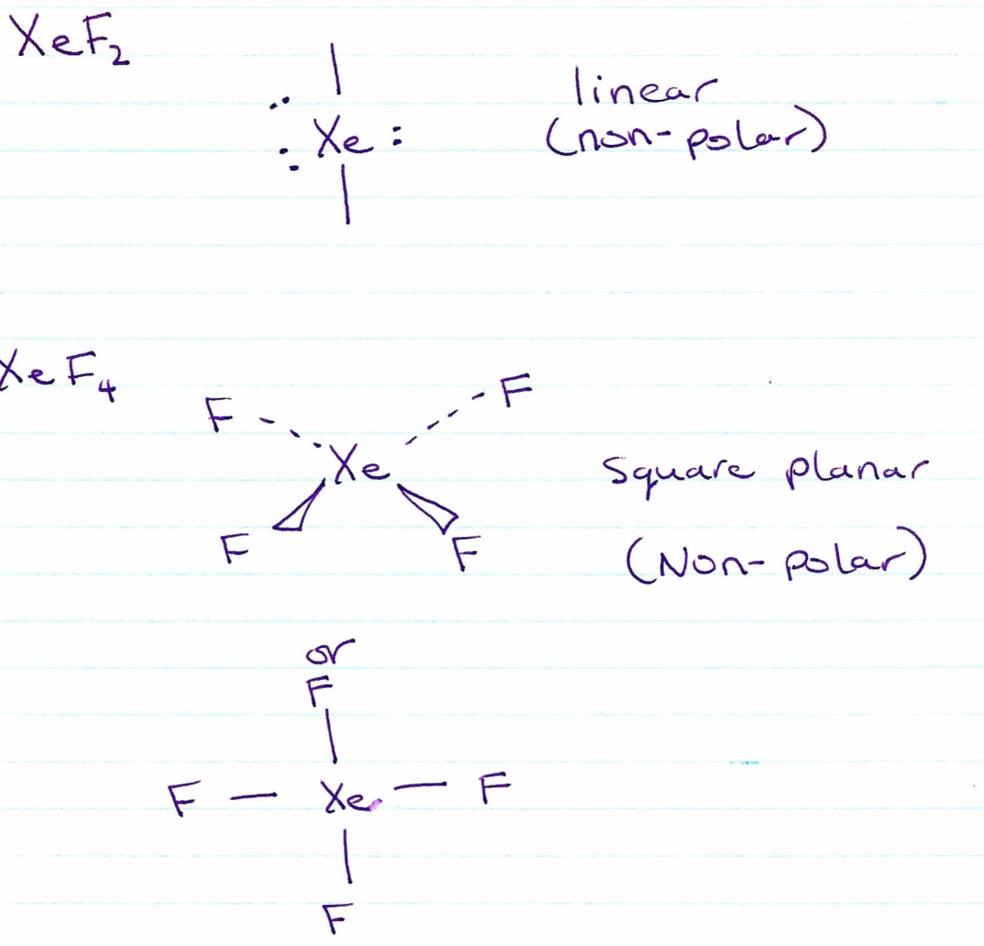
7. Determine whether each of the compounds in #6 is polar.
8. Which compounds in #6 required electrons to be promoted to form a hybrid orbital? Name the hybrid orbital formed.
a) HCN sp hybrids
b) CO₃²⁻ sp² hybrids
c) PBr₃ no hybridization necessary
d) SiCl₄ sp³ hybrids
e) PBr₅ sp³d hybrids
f) SF₄ sp³d hybrids
g) SF₆ sp³d² hybrids
h) BrCl₃ sp³d hybrids
i) XeF₂ sp³d hybrids
j) XeF₄ sp³d² hybrids

9. Determine the intermolecular force acting on each substance in #7.
a) HCN polar therefore dipole-dipole and London forces
b) CO₃²⁻ non-polar London forces (and ionic)
c) PBr₃ polar therefore dipole-dipole and London forces
d) SiCl₄ non-polar therefore London forces
e) PBr₅ non-polar therefore London forces
f) SF₄ polar therefore dipole-dipole and London forces
g) SF₆ non-polar therefore London forces
h) BrCl₃ polar therefore dipole-dipole (minor since only very slightly polar) and London forces
i) XeF₂ non-polar therefore London forces
j) XeF₄ non- polar therefore London forces
10. Which compound has the stronger London forces: PBr₅ or SF₆? Justify your choice. PBr₅ (190) has more electrons than SF₆ (70).
The strength of London forces is determined by the number of electrons – the more electrons that are moving around in a molecule, the greater number of as well as the stronger temporary dipoles are created.
11. Which compound has the stronger dipole-dipole force: PBr₃ or SF₄? Justify your choice.
Both molecules are polar and therefore have dipoles. The Δen for the P-Br bond is 0.70; for S-F it is 1.7. Therefore the dipole in SF₄ is greater than in PBr₃ which means that the dipole-dipole acting between SF₄ molecules is greater than between PBr₃ molecules.
12. Which compound has the stronger hydrogen bonding: CH₃OH (methanol) or HOCH₂CH₂OH (ethandiol)? Justify your choice.
Both molecules have H-O bonds and therefore have hydrogen bonding acting between the molecules. Ethandiol has twice the number of hydrogen bonds.

13. Consider the following pairs. Predict which has the higher boiling point. State the main reason why.
a) XeF₂ , XeF₄ both non-polar therefore only London forces at work. The number of electrons in the molecule is the greatest factor that impacts strength of London forces. Since XeF₄ has more electrons it will have the highest boiling point.
b) H₂, F₂ both non-polar therefore only London forces at work. The number of electrons in the molecule is the greatest factor that impacts strength of London forces. Since F₂ has more electrons it will have the highest boiling point.
c) CH₂Cl₂, CCl₄ CH₂Cl₂ is polar therefore has dipole-dipole and London forces at work. CCl₄ has only London forces since it is non-polar. However this is difficult to determine which will have the higher boiling point since one could argue that CH₂Cl₂ has dipole-dipole and CCl₄ does not it would cause it to have the highest. However, CCl₄ has greater London forces (greater number of electrons) therefore one could argue that it has the greater boiling point. In actual fact, the boiling point of CH₂Cl₂ is 39.6ºC and CCl₄ is 76.7ºC so the greater London forces wins.
d) H₂O, H₂S
Both are polar. H₂S has dipole –dipole and London forces at work; H₂O has Hydrogen bonding and London forces at work. The hydrogen bonding in water far outweighs the greater London forces in H₂S and therefore water has the highest boiling point.
- Try also the self-quizzes for chapters 3 and 4 and Unit 2

